Siddhanta Shiromani
Grahaganit adhyaya
Madhyamaadhikare Pratyabdhasuddhipakramah
(Section I, Chapter 5 : Corrections)

Verse No | Translations
1 | Multiplying the number of years that has elapsed from the beginning of the Aeon with 2 Days 4 Dandaas and 3 Palas (Dinadi) and dividing the product by 8 and then adding this quotient with the number of years that has elapsed from the beginning of the Aeon and dividing this sum with 7 we will have the Lord of the year starting with the Sun.  Bimala Prasada Siddhanta Saraswati’s Note :  According to Siddhnata Shiromani a year consists of 365 days, 15 Dandaas, 30 Palas, 22 Vipalas and 30 Anupalas. Dividing 365 by 7 we have 1 as the remainder. So  15 Dandaas, 30 Palas, 22 Vipalas, 30 Anupalas x 8 = 2 Days 4 Dandaas 3 Palas  = (Abdavrinda x 2 Days 4 Dandaas 3 Palas) ÷ 8  Abdavrinda = Lord of the first day of a year starting from Sunday.
2 | Half the number of the number of years that has elapsed from the beginning of the Aeon added to ¹/₈₀ of itself, then divided by 60 and added to ¼ of the number of years that has elapsed from the beginning of the Aeon, gives Dinadi. If we divide successively the number of years that has elapsed from the beginning of the Aeon by 4, 120 and 9600 we will have the same measure of Dinadi.  Bimala Prasada Siddhanta Saraswati’s Note :  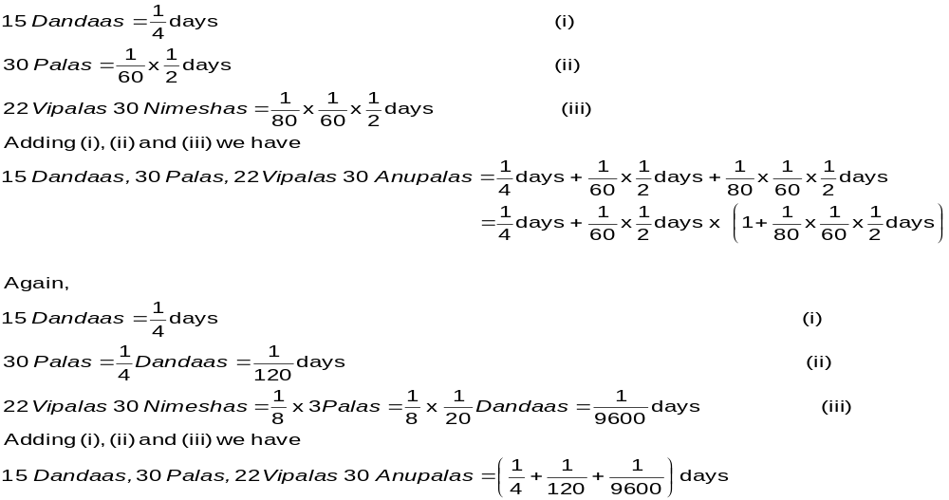

Verse No | Translations
3 | If we add ¹/₆ of the number of years that has elapsed from the beginning of the Aeon to itself and add to this sum 30 times the number of years that has elapsed from the beginning of the Aeon and divide this sum by 120 and subtract the quotient from the number of years that has elapsed from the beginning of the Aeon we will have the number of elapsed Avamas.  Bimala Prasada Siddhanta Saraswati’s Note :  We know there are 4,320,000,000 years in an Aeon and 25,082,550,000 Avamas in an Aeon. So in each year there is 5 days, 48 Dandaas, 22 Palas and 7.5 Vipalas or about 6 Avamas. This when subtracted from the total days of a year we have 11 Dandaas, 37 Palas, 52.5 Vipalas. Multiplying this by 160 we have 31 days and 1 Dandaas. Hence  5 + (1 - 11 Dandaas, 37 Palas, 52.5 Vipalas) = 5 + (31 days and 1 Dandaas) ÷ 160.
4 | Multiplying the Dinadya by 3 add to it ¹/₃₀ of number of years. Subtracting ¹/₄₀₀ of the number of years from this sum we will have the Kshayaaha (omitted lunar days). Subtracting ¹/₅ of the number of years from itself and adding to it ¹/₁₆₀ part of the difference between itself and ¹/₆₀ part of it we will have the Kshayadina (omitted lunar days).  Bimala Prasada Siddhanta Saraswati’s Note :  From the first verse we know the remaining day part in a year is 15 Dandaas, 30 Palas, 22.5 Vipalas and from the previous verse we know the Avama part in a year is 48 Dandaas, 22 Palas and 7.5 Vipalas. Now 3 times the remaining day part of the year is = 3 x 15 Dandaas, 30 Palas, 22.5 Vipalas = 46 Dandaas, 31 Palas, 7.5 Vipalas. Subtracting this from the Avama part in a year we have 1 Pala 51 Vipala as the remaining or it can be said : 0 Dandaas, 2 Palas, 0 Vipalas - 0 Dandaas, 0 Palas, 9 Vipalas, which is respectively one-thirtieth and one-four-hundredth part of a day. Hence :  Again,  One-fifth of a year is 0 Dandaas, 12 Palas. When we subtract this from 1 year (number of years=Abda Sankhya) we have 0 Dandaas, 48 Palas. Now difference of 1 year from one-sixtieth part of itself is = 0 Dandaas, 59 Palas. Now dividing this by 160 we have 0 Days, 48 Dandaas 22 Palas and 7.5 Vipalas. Adding these we have the yearly Avama as 0 Days, 48 Dandaas, 22 Palas and 7.5 Vipalas. Hence we have

Verse No | Translations
5 | To the sum of Dinadi and Kshayaaha if we add 30 times number of years and divide this sum by 30 we have the number of intercalary months. The fractional part is known as the Suddhi from which we normally subtract the Unaha Naari (fractional part of Kshayaaha).  Bimala Prasada Siddhanta Saraswati’s Note :  For each year, the fractional part of day is 15 Dandaas, 30 Palas, 22.5 Vipalas and the fractional part of omitted lunar days is 48 Dandaas, 22 Palas and 7.5 Vipalas. Adding these two we have 1 day 3 Dandaas 52 Palas and 30 Vipalas. In a year the number of lunar day is 371 Days 3 Dandaas 52 Palas and 30 Vipalas. Subtracting throm the 360 days of a solar year we have the remainder as 11 Days 3 Dandaas 52 Palas and 30 Vipalas. So adding to the above mentioned sum 10 times number of years we have the number of intercalary days. Dividing this by 3 we determine the number of intercalary months. Hence,  The remainder is called Suddhi, we can ignore that.
6 | The number of years is kept separately at three places; to one we multiply 11, we divide the second one with 32 and the third is divided by 30. These three operations on number of years when added together and this sum is divided by 30 will give us the number of intercalary months (Adhimaasa) and the remainder from the division is called Suddhi. As said above, from this Suddhi we normally subtract the Unaha Naari (fractional part of Kshayaaha).  Bimala Prasada Siddhanta Saraswati’s Note :  For each year, the intercalary part is 11 Days 3 Dandaas 52 Palas and 30 Vipalas. As it is difficult to multiply the number of years by this fraction, hence Bhaskara says of an alterative method. One-thirtieth part of this is 2 Dandaas and one-thirty second part of this is 1 Dandaas 52 Palas and 30 Vipalas. When all these are added together we have 11 Days 3 Dandaas 52 Palas and 30 Vipalas. Hence  Dividing the Adhidina (intercalary days) by 30 we will have the number of intercalary months (Adhimaasa).
7 | If we subtract the number of intercalary months from the number of years that has elapsed from the beginning of an Aeon, multiply this difference by 2, subtract this product from the omitted lunar days, correct this difference with the Suddhi (as mentioned above) and divide it by seven we will have the lord of the year (i.e. the week-day) at the commencement of the solar year.  Bimala Prasada Siddhanta Saraswati’s Note :  The week-day that fall at the Ahargana of the end of a solar year is the Lord of the year for that year. A solar year consists of 360 days so there are 3 week days at the end of it and as a month have 30 days there are 2 week-days at the end of it. Now the difference between he solar and the lunar year is 5 days, 48 Dandaas, 22 Palas and 7 Vipalas 30 Anupalas. So if we subtract 5 week-days from each year, we have the lord of the year moves by 2 week days before.
8 | The fractional part of the intercalary months (i.e. Adhimaasasesha in Dandaas) when reduced by the fractional part of the Dinadya (in Dandaas) gives us the fractional part of the omitted lunar days (i.e. Kshayasesha in Dandaas).  Bimala Prasada Siddhanta Saraswati’s Note :  The days of intercalary month are the sum of Dinadi and Avama. Hence if we subtract the fractional part of Dinadi from the fractional part of the intercalary month we get the fractional part of Avama.

Verse No | Translations
9 | Multiplying the number of years elapsed with the number of revolutions of a planet for an Aeon and dividing that product with the number of years in an Aeon gives us the revolution during its conjunction with the sun. Likewise we determine the node (Pata), commutation (Shighrocca) and mean anomaly (Mandocca).  Bimala Prasada Siddhanta Saraswati’s Note :  The sun completes one revolution in a year; hence we have in a year the end of a solar revolution. If the years of an Aeon corresponds directly to the number of revolutions for a planet, it would not be difficult to ascertain the number of revolutions in the years that has elapsed from the beginning of the Aeon. We have described the process of calculating the number of revolutions from the Aharganas, hence we describe the process of determining the revolutions in the years that has elapsed from the beginning of the Aeon. As the speed of node (Pata) and mean anomaly (Mandocca) is slower, we can use this method to determine their number of revolutions.
10 | If we multiply the fractional part of the intercalary month by 12 we have a degree which is the mean position of the Moon.  Bimala Prasada Siddhanta Saraswati’s Note :  The difference between the solar and the lunar day is the fractional part of the intercalary month. So multiplying this by 12 tells us the difference in degrees in the position of sun and the moon. At the end of a solar year, as the mean position of the sun is at beginning of Aries, the mean position of the Moon lies there too.
11 | Using the above method we can determine the factional part of the day (Dinadi) from the beginning of KaliYuga (Iron Age). For this we have to add the lord of the year starting from Friday and the fixed points of the planets in the KaliYuga (Iron Age).  Bimala Prasada Siddhanta Saraswati’s Note :  At the beginning of Kali Yuga we have determined the position of the planets (Dhruvakas) after determining the Aharganas and Abdaganas. So we can consider these three things to be determined. Bhaskara has given a detailed instruction in the Golaadhyaya part of this book about how we can determine the planetary position by observing the speed of the planet.
12-13 | If we take the difference of solar and lunar years we have a fractional part in Dandaas (Kshayadandaas). If we add one-twentieth of this fractional part to itself we have a result which imagined as the Dinadi is known as the Kshepadinadi (fractional part of the omitted lunar day) and is used in determination Dinagana. We subtract the Suddhi from the number of elapsed lunar days from the beginning of the solar year. To this difference if we add ¹/₇₀₂ parts of itself and the Kshepadinadi and then divide this sum with 64 we will have the omitted days (Dinakshaya). If this be subtracted from the sum of the Suddhi and number of elapsed lunar days from the beginning of the solar year we will have the Aharganas from the beginning of the year.  Bimala Prasada Siddhanta Saraswati’s Note :  Number of elapsed lunar days – Suddhi – Tithikshaya = Aharganas  Suddhi = Fractional part of intercalary month (Adhimaasasesha) – Fractional part of omitted lunar days (Avamadya)  which are determined on the basis of the lunar days. So from the mean of a lunar day if we subtract intercalary days we will have the fractional difference part of the lunar week day in Dandaas. We have to use rule of proportion if we want to determine the fractional part of omitted lunar days (Avamadya) less complete day from a specific Avamadya. If we take 64 days to make 1 Avama, we derive at the above equation.

Verse No | Translations
14 | If the Suddhi is greater than the elapsed lunar days, then we have to take the Suddhi as determined for the previous year and determine the Aharganas accordingly after we have considered the number of elapsed lunar days from the beginning of the previous solar year. In this case we have to consider the planetary positions (Dhruvakas) according to the previous years.
15 | If we diminish the number of days (Dinagana) by ¹/₆₀ part of itself and add to this result thrice the number of days (Dinagana) divided by 22 we will get a result in Kalaas which would be the mean position of the sun.  Bimala Prasada Siddhanta Saraswati’s Note :  The daily speed of the sun = 0 Days 59 Dandaas 8 Palas 10 Vipalas 21 Anupalas x Dinaganas  Here the full disc.
16 | If we multiply the number of elapsed lunar days by 12, we get a result in degrees. When this result is added to the corrected position of sun we will have another sum. To this sum if we add ten times of the Kalaas obtained by adding Kshayaahasesha (as described in verse 13) to one-seventh of itself, we will have the corrected position of the moon.  Bimala Prasada Siddhanta Saraswati’s Note :  If one-twelfth of the difference between sun and moon’s position is Tithi (lunar days), then multiplying tithi by 12 we will get the difference in the position of sun and moon. The mean of the times of mid-lunar day and the rise the moon is called Kshayaahaadya. This is in solar days; to convert it to lunar days we have to multiply it with 64 and divide it with 63. Later if we multiply it with Kalaas of 12 Angshaas (i.e. 12 x 60 = 720) we get the result in Kalaas. Hence  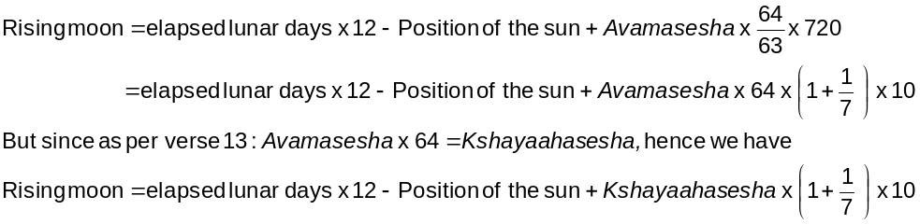
17 | Keep the half of the number of civil days as Kalaas and multiply next half with 3 and add this product to the degrees. Again subtracting ¹/₁₇ part of the number of civil days from it and adding this difference to the mean position of the Mars at the beginning of the year we will get the mean position of the Mars at a given time.  Bimala Prasada Siddhanta Saraswati’s Note :  Mean position of Mars = its position at the beginning of the year + ½ x no of civil days (in degrees)  + ½ x no of civil days (in minutes) x 3 – ¹/₁₇ x no of civil days (in minutes)  Now , ½ x no of civil days (in degrees) = 0 Angsha 30 Kalaas and ½ x no of civil days (in minutes) x 3 = 1 Kalaa 30 Vikalaas.  Adding these two we have 0 Angshas 31 Kalaas 30 Vikalaas. Now ¹/₁₇ of no of civil days is = 0 Angshas 0 Kalaas 3 Vikalaas 31.9 Anukalas. Subtracting this from the above sum we have = 0 Angshas 31 Kalaas 26 Vikalaas 28.1 Anukalaas which can be compared to the daily motion.

Verse No | Translations
18 | To the position of the apex of fastest motion for Mercury at the beginning of the year if we add four-times the number of civil days and twelve times number of civil days divided by 130 we will get the position of Mercury.  Bimala Prasada Siddhanta Saraswati’s Note :  Apex of fastest motion for Mercury = Apex of fastest motion for Mercury  If we take Ahargana as 1 we have the result as 4 Raashis, 5 Angshas, 32 Kalaas, 18 Vikalaas, 28 Anukalas, this is the daily motion of Mercury.
19 | To the position of Jupiter at the beginning of the year we add 12 degrees of number of civil days and subtract from it ¹/₇₁ parts of itself in minutes we get the mean position of Jupiter.  Bimala Prasada Siddhanta Saraswati’s Note :  If we Ahargana as 1 we have 0 Raashis, 4 Angshas, 59 Kalaas, 9.2 Vikalaas as the daily motion of Jupiter.
19 | If we add ten-times number of civil days divided by 6 (in degrees) to the position of apex of fastest motion for Venus and subtract from this sum ten-times number of civil days divided by 155 (in degrees) we get the position of the apex of fastest motion for Venus at that day.  Bimala Prasada Siddhanta Saraswati’s Note :  If we take Ahargana as 1 we have 1 Raashi, 36 Angshas, 7 Kalaas, 44.6 Vikalaas as the daily motion of Venus.
20 | We divide the number of civil days for the position of Saturn at the beginning of the year into two parts and multiply each of them by 2. Then convert one to minutes and divide the second by 5 and then convert it to seconds. Then add all of them to yield the mean position of Saturn.  Similarly, to the apex of the moon at the beginning of the year if we add one-tenth of number of civil days and ¹/₈₈ part of it we get the apex of moon.  Bimala Prasada Siddhanta Saraswati’s Note :  Taking Aharganas as 1 we have the daily motion of Saturn as 2 Kalaas 0 Vikalaas 22.9 Anukalaas.  The daily motion of Moon as 6 Kalaas 40 Vikalaas 53.9 Anukalaas.

Verse No | Translations
21 | To the position of the Pata (node) at the beginning of the year if we add 30 times number of civil days divided by 566 we will get a result in degrees which is the position node of the moon. This node is known as Raahu and Tama.  Bimala Prasada Siddhanta Saraswati’s Note :  Taking Aharganas as 1 we have the daily motion of Saturn as 3 Kalaas 10 Vikalaas 48.3 Anukalaas.
22-24 | We multiply the number of civil days by 100,000. Then dividing this product by 101,461 for Sun, 151,787 for Moon, 190,833 for Mars, 24,436 for Mercury, 1,203,400 for Jupiter, 62,416 for Venus, 2,990,000 for Saturn 898,000 for Apex of Moon, 1,886,800 for Rahu and for mean position of the moon we multiply the product by additional 20 we will have a result individually. If we add these individual results to the position of each of them, we will have their individual mean positions.  Bimala Prasada Siddhanta Saraswati’s Note :  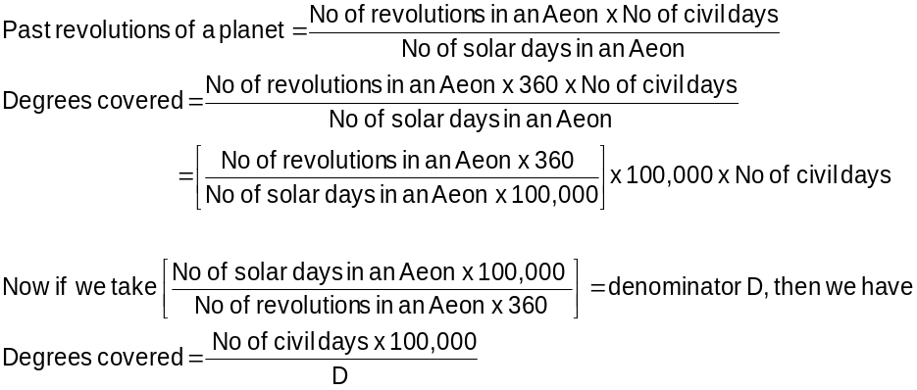  For moon the denominator D is already multipled by 20. In this case the denominator would be 75893.50.
25 | The number of minutes of arc moved by a planet per day gives the mean daily motion of that planet.
26 | The spatial speed of the planets measured in Yojanas covered each day in the sky is same. In angle (minutes of the arc) however the speeds of the planets differ. So we perceive slowness or fastness in their movements.
27 | All the planets have same circular path consisting of 21600 Kalaas. But it is due to the vastness or shortness of the circular path we have different speeds of different planets. The smaller orbit has a smaller spatial distance that requires to be covered and a longer orbit has a longer spatial distance to be covered. The speed being constant the evidently the longer orbit will take apparently more minutes of arc to be covered. Hence the Mercury, Venus, Sun, Jupiter and Saturn being placed at a longer distance from the Moon in ascending order their orbits are longer in ascending order, so they are slower in angular motion in that order.
Hence ends the chapter named Madhyamaadhikare Pratyabdhasuddhipakramah
of Grahaganita part of Siddhanta Shiromani

There is an inconsistency here. Bimala Prasada Siddhanta Saraswati says in the translation of the verse that the sum be divided by 120 but in the note he mentions 160. Also the note apparently does not seem to expound on the given verse.
There are several inconsistencies in the translation of this verse. Bimala Prasada Siddhanta Saraswati says of Dinadya and Kshayaahas but we have to really guess what this means because he does not give any explanation of these terms. Also his usage of Abdavrinda and Abdagana is also not consistent. In general the translation is quite ambiguous starting from verse 1 of this chapter.
That is 15 Dandaas, 30 Palas, 22 Vipalas, 30 Anupalas
Inconsistency! Does he mean Tithikshaya = Kshayaahasesha ?
This entire note is ambiguous.
Although Bimala Prasada Siddhanta Saraswati starts giving us accounts of daily motions from this verse he does not mention any unit. I have taken it to be in degrees-minutes-seconds, which seems to be a logical one.
Mutilated portions and ambiguous phrasing of sentences makes this entire note very very difficult to understand. I have tried my best in translating this but I can’t shake of the feeling hat something is wrong somewhere.
Very much ambiguous translation. This is what I could make out from the total text given.

